New FSEA Service Line Guide

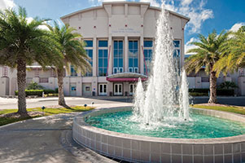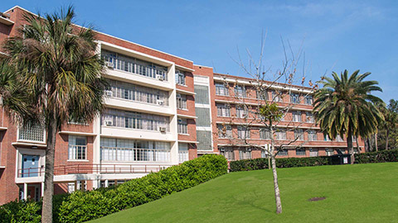

CONTENTS

**How to Complete a New FSEA Service Line Form** 3

**Information You’ll Need** 5

**Appendix** 5

**I.** **Section 2 Questions** 5

**Other Helpful Resources** 6

# **How to Complete a FSEA New Service Line Form**

Auxiliary Accounting is launching an electronic FSEA New Service Line Form to accurately document the general information and financial operating plan of new service lines being added to previously approved Fee-for-Service Education Activities (FSEA) from University departments. The FSEA New Service Line Form is a new OnBase system form that works best with Firefox. A sample of the form is available on our [Auxiliary Accounting Website](https://www.fa.ufl.edu/departments/auxiliary-accounting/).

This guide lists the information you need prior to completing the form as well as the steps for completing the main areas of the New Electronic FSEA New Service Line Form.

1. Visit our [Auxiliary Accounting Webpage](https://www.fa.ufl.edu/departments/auxiliary-accounting/) to submit a **New FSEA New Service Line Form** .
   * GatorLink authentication is required to access the online form.
2. Read the introduction of the electronic FSEA New Service Line Form before completing the sections.
   * The introduction provides general information and instructions you need to follow to complete all sections.
3. Complete all the sections of the FSEA New Service Line Form .

**FSEA New Service Line Form Sections:**

* **Section 1: Unit Contact Information**
* **Section 2: General Information**
* **Section 3: Department Approvers**
* **Form Submission**

1. Search for the approved FSEA and enter all applicable FSEA unit contacts in **Section 1.**

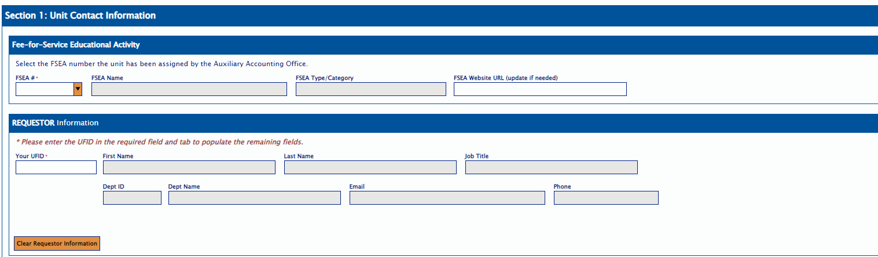

* + Enter the FSEA # that was previously provided to you. This is the same as your department UBI#.
    - The FSEA information will auto-populate once you enter the FSEA #.
  + Enter your UFID or the UFID of the person for whom you are completing the form in the **Requestor** information.
    - The contact information will auto-populate once you enter the UFID in the **Requestor** section.
    - Click on the "**Clear Requestor Information"** to update the **Requestor’s** UFID if incorrect.

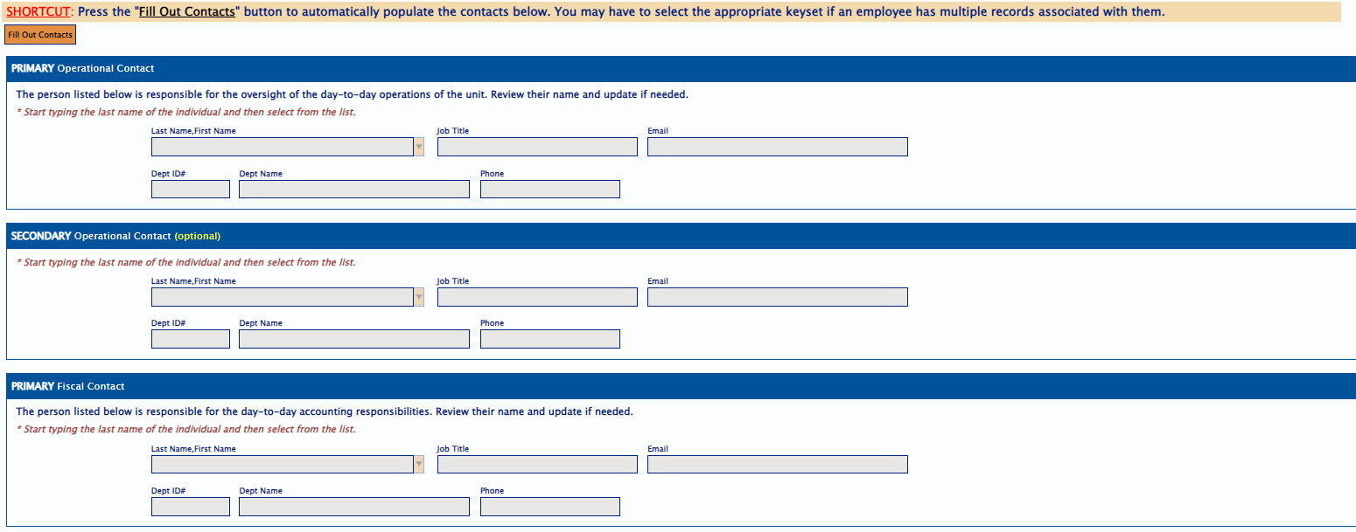

1. Press the “Fill Out Contact” button to automatically populate the contacts that are already on file for the FSEA. Complete all applicable questions **1 through 7** from **Section 2** of the form.
   * The **General Information** section assists the Auxiliary Accounting office in identifying the previously approved FSEA’s operational information and allows the unit to document the new service lines.
   * This section will confirm whether the new proposed service line(s) differs from existing FSEA services.
   * Select the **Fill Out Chartfield and Rates** button toautofill the **Assigned Chartfield** and **Proposed Rates** table. The tables will show the approved Chartfield and rates for the existing service lines.

* + Click on the **Add** button to add the proposed Chartfield.

* + Click on the Add button to add the New Service Line(s) name(s), flex code (if applicable), unit of measure, rates (Internal, External Not for Profit, External for Profit, Other), brief description and effective date. FSEA # and FSEA Name will carry over.

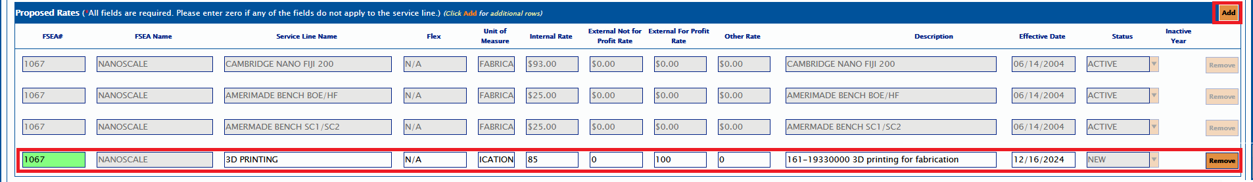

* + Under the Rate Documentation section, attach the completed **FSEA New Service Line Workbook.** A template form is available here: ([link to spreadsheet](https://www.fa.ufl.edu/directives/modify-an-existing-fee-for-service-educational-activity/)). You cannot submit the OnBase Form without the **Excel Workbook** (required field).Please attach **any supporting documentation** in the designated section as well.
  + For details on **Section 2**, please review the information available on our [Auxiliary Accounting website](https://www.fa.ufl.edu/directives/creating-a-fee-for-service-educational-activity/) or in **Appendix I** (Section 2 Questions) from this document.

1. Enter the approvers or highest accountable administrators who will certify/recommend the approval of this request under **Section 3**.
   * Search by **Last Name** to complete the **Department Chair/Director** Approver **and Dean/Vice** **President** Approver contacts.
     + The **Department Chair’s** contact must be different from the **Dean/VP**.

1. Complete all **required** FSEA New Service Line Form fields before submitting it.
2. Submit the FSEA New Service Line Form for approval.
   * After submitting, you will receive a thank you email with a link to OnBase for future access if needed.
   * The OnBase Form will first be routed to the Auxiliary Accounting office for a preliminary review and then routed to the department’s approvers for approval.

**Remember**

* Your Single-Sign-On authentication will **time out after 20 minutes** of inactivity. Be sure to **save** your form if you cannot complete and submit it without a 20-minute delay, or **you will lose your progress**.

**If you need assistance, please email** [ga-aux@ad.ufl.edu](mailto:ga-aux@ad.ufl.edu)**, or call (352) 294-7236, or visit our** [**Auxiliary Accounting Website**](https://www.fa.ufl.edu/departments/auxiliary-accounting/) **for additional information.**

# **Information You’ll Need**

Here is the information you should gather before completing the FSEA New Service Line process:

* FSEA New Service Line Workbook ([link to spreadsheet](https://www.fa.ufl.edu/directives/modify-an-existing-fee-for-service-educational-activity/)). The Excel Workbook assists the Unit in providing details about the financial plan, target customer(s), type of service line(s), and projected operating revenue and expenses of the FSEA activity to calculate the service line(s) rates.
* Approval from highest accountable administrators of your college.
* Any additional supporting documentation for the proposed FSEA New Service Line activity, such as market rate comparisons, descriptions of the activity processes, capital equipment (cost>$5000) to be utilized 100% in the FSEA activity, etc.

# **Appendix**

## **Section 2 Questions**

1. **Proposed Unit Name?**

* This will be used as a guide for the future naming of the Fee-for-Service Educational Activity if approved.

1. **Physical Address of Proposed Unit (do not use a P.O. Box)?**
   * Enter the Building Number, Building Name, Floor #, Room Number, Additional Location.
   * List all locations where the goods/services will be provided in the **Additional Location** box.
2. **Describe the proposed New FSEA Service Line Activity?**

* The description of the FSEA activity is a narrative of what the unit does and which goods/services it offers customers.

1. **Is a fee currently charged for the services/products?**

**4a. If yes, provide new service line activity start date and with which chartfield the revenue was collected**

1. **Do you propose to have sales with External Customers?**

**5a.** **Please provide a narrative that explains how the service meets the following criteria:**

--- The service is not readily available outside the University.

--- The service has a research purpose or helps educate students.

--- The service does not compete with the private sector

**5b**. **How will any potential excess revenues from external customer be spent?**

1. **Will there be any contracts with external customers?**
2. **Will the New Service Line operate in a different Chartfield from the ones listed below?**

* If the Chartfield is different for the new service line, it will need to be approved before the new service line can begin operating.

# **Other Helpful Resources**

1. [Creating a New FSEA Service Line Activity](https://www.fa.ufl.edu/directives/modify-an-existing-fee-for-service-educational-activity/)
2. [New Service line OnBase Form Sample](https://www.fa.ufl.edu/directives/modify-an-existing-fee-for-service-educational-activity/)
3. [Setting up a Fee‐for‐Service Educational Activity](https://www.fa.ufl.edu/directives/setting-up-the-approved-fsea/) (same process for New FSEA Service Line)